World Federation of the Deaf’s
2020 Global Leaders Challenge!

#IDSignLanguages
#SignLanguagesForEveryone

Concept Note

The World Federation of the Deaf (WFD) and deaf communities around the globe celebrate the International Day of Sign Languages (IDSL) on 23 September each year, as part of the International Week of the Deaf (IWD). This celebration arises from the Resolution A/RES/72/161 of the United Nations adopted in 2017, which recognises 23 September as the International Day of Sign Languages.

The International Day of Sign Languages is an unique opportunity to promote and support the linguistic identity and cultural diversity of all deaf people and sign language users. Every year, the International Day of Sign Languages and the International Week of the Deaf are celebrated under a specific theme.

The theme for the 2020 International Day of Sign Languages is “Sign Languages are for Everyone!”

The theme for the 2020 International Week of the Deaf (IWD) will be “Reaffirming Deaf People’s Human Rights”.

To celebrate the International Day of Sign Languages 2020, the WFD is launching a Global Leaders Challenge! This challenge aims to promote the use of sign languages by local, national, and global leaders in partnership with national associations of deaf people in each country, as well as other deaf-led organisations.

Your country leaders - might they be government officials, members of parliament, members of city council - should sign in your national sign language “[name of your national sign language] is for Everyone!”.

For example:
“Ghanan Sign Language is for Everyone!”;
“La Langue des Signes Belge Francophone est pour tous”, and so on.

In addition your country leader should challenge other leaders to take over the challenge! For example, your Prime Minister could challenge its Minister of Education or Minister of Culture to do the same video. Alternatively, your country leader could also challenge a leader from another country. However, we encourage several leaders within the same country to undertake the challenge.

The Global Leaders Challenge is a unique opportunity for national associations of deaf people to establish and maintain sustainable collaborations with their political leaders through the use of their national sign languages.

Guidelines
Contact your political leaders and ask them to make a video of themselves signing in your national sign language “[your national sign language] is for Everyone! You can provide technical support to them as needed and even appear in the video as a special guest;
WFD Ordinary Members and Associate Members can send the videos to the WFD at idsl@wfdeaf.org by 1 September 2020. In your emails please indicate the full name, title and position of the leader(s). Then share the video on your social media from 23 September 2020 onwards;

Encourage your leaders to communicate on their social media with #IDSignLanguages and #SignLanguagesForEveryone before September 23rd 2020 about their participation in the 2020 Global Leaders Challenge by publishing a picture of their video;

Advocate for your National TV Broadcast channels to release the videos at peak hours on 23 September 2020 during the International Day of Sign Languages;

On 23 September 2020, during the International Day of Sign Languages, the WFD will release a specific page on their website highlighting all the Global Leaders Challenge videos;
The aim is for all videos to be shared on both the World Federation of the Deaf and on National Associations of the Deaf’s social media channels, as well on your National TV Broadcast channel on 23 September 2020, the International Day of Sign Languages, with the following hashtags: #IDSignLanguages, #SignLanguagesForEveryone.

Congratulations, you have contributed to the promotion, visibility
and growth of your national sign language!

Some advice for video shooting

Background and Framing

The videos should be in landscape mode.

If it's a video without overlay, the background must be a plain colour or be completely neutral.

If it’s a video with overlay, you can use the background that WFD provides for with the International Day of Sign Languages.
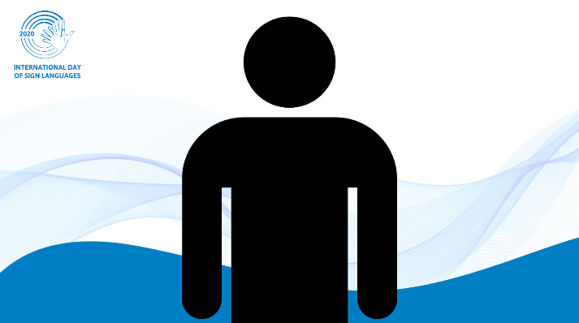

Brightness

The lighting must be sufficient to allow good visibility. You have to keep a good contrast between the background and the person signing.

Video Format

The WFD accepts videos in mp4 and mov format.

